**FIA1 Draft**

**Introduction:**

The required task is to develop a function that models the shape of a waterspout from a water bubbler and to generate a detailed report explaining how to develop and refine the model. Multiple functions will be produced to explore the most accurate modelling of the water spout. These functions will be collated and referred to, to add more data sources to the report. One of the functions with be selected, validated, and justified by the coordinates collected from the parabola.

**Assumptions:**

It can be assumed that the camera was placed as perpendicular as possible to the waterspout when taking the photograph because it assists in not skewing the photo, creating more accurate points. It can also be assumed that the camera was in focus and that the printer has a high-quality print because this affects the overall consistency of the graph and the plotting of the coordinates. It is also assumed that outside forces such as wind and varying water pressure will not affect the graph's dilation, turning point, and overall width, because they impact the accuracy of the quadratic function. It is assumed that a narrower graph will have a higher R2 value than a wider one due to the lesser area for abnormalities in the data range.

**Observations:**

It can be observed that each coordinate on the graph is spaced out evenly along the parabola of the waterspout because this correlates to the accuracy of the modelled function. It can also be observed that the dilation will be negative (a reflection) because the waterspout does not defy Newton’s laws of physics and will fall back to earth due to gravity. It can also be observed that the dilation will be a fraction because the x value range is larger than the y value range creating a wide graph, and thus a fraction instead of a whole number. It can also be observed that the R2 value will never be 1 because it is practically impossible to achieve a perfect parabola where the trendline passes through all the points due to nature and the possibility of human error.

**Mathematical Translation:**

Throughout this task, it is required to use advanced mathematical formulas and concepts to calculate and refine the function and modelling inside of excel and desmos. After plotting all of the coordinates and finding the turning point–the H & K Values–and the x-intercepts they are used to calculate the a-values–the dilations–using the turning point formula: y = a(x - h)2 + k. Both x-intercepts and higher power polynomials– $x^{3}$ $x^{4}$ $x^{5}$ $x^{6}$–will be used to calculate their respective formula in order to generate the highest possible valid R2 value. The R2 value is a range from 0 to 1 which determines the accuracy of a trendline to its coordinates with the latter being the most accurate. The R2 and multiple formulas assist in determining the validity of the solution as it compares multiple different parabolas on the task to calculate the best graph and formula.

**Solve:**

The 1st step was to locate, photograph, and print an appropriate waterspout considering the assumptions and observations. The final waterspout photograph that was chosen qualifies with the assumptions and the observations is displayed in Figure 1.

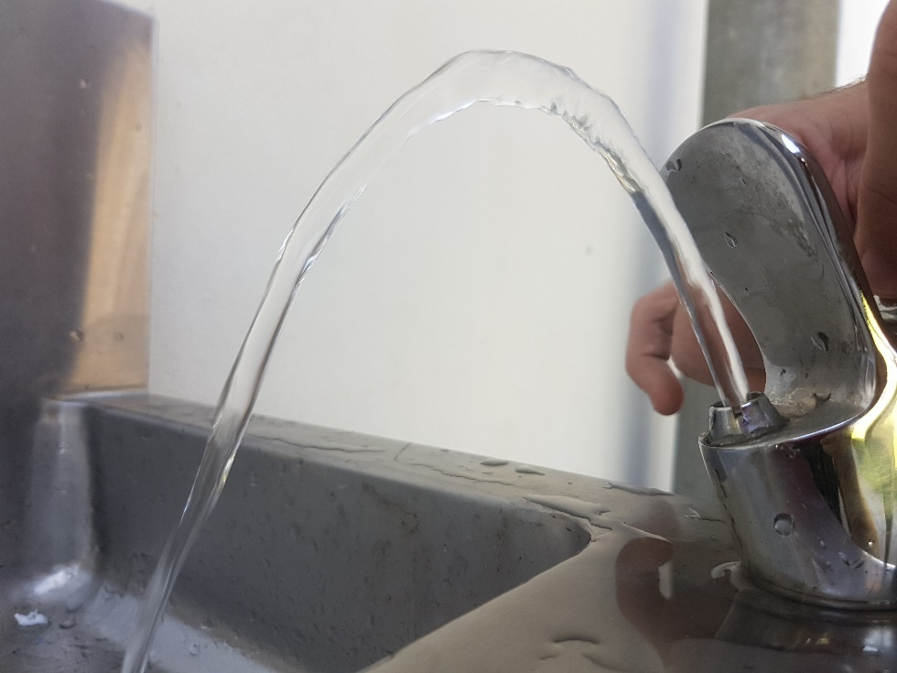**Figure 1**

The 2nd step was to transcribe the waterspout data points onto the cartesian plane, ensuring that each coordinate was placed appropriately according to the original photograph.

The 3rd step was to list out the coordinates so that they could be transferred into Microsoft Excel and Desmos for further development. The full list of coordinates are shown in Figure 2.

**Figure 2**

|  |  |
| --- | --- |
| 0 | 0 |
| 1 | 1.5 |
| 1.5 | 3.5 |
| 2.5 | 5.5 |
| 3.5 | 7.5 |
| 4 | 9.5 |
| 5 | 11.5 |
| 5.5 | 13.5 |
| 6.5 | 15 |
| 7 | 17 |
| 7.5 | 18.5 |
| 8 | 20 |
| 9 | 23 |
| 10 | 24.5 |
| 11 | 27 |
| 12 | 29.5 |
| 13 | 32 |
| 14 | 34 |
| 15.5 | 35.5 |
| 16.5 | 37 |
| 18 | 39 |
| 19 | 40 |
| 20.5 | 41.5 |
| 22 | 43.5 |
| 24.5 | 45.5 |
| 26 | 46 |
| 27 | 47 |
| 29 | 47.5 |
| 30.5 | 47 |
| 32 | 46.5 |
| 34 | 45.5 |
| 35.5 | 44.5 |
| 37 | 42.5 |
| 38.5 | 41 |
| 39.5 | 39 |
| 41 | 37 |
| 42 | 35.5 |
| 43 | 34 |
| 43.5 | 32.5 |
| 44 | 31 |
| 45 | 29.5 |
| 45.5 | 28 |
| 46 | 26.5 |
| 46.5 | 25.5 |
| 47.5 | 23 |
| 48 | 22 |
| 48.5 | 20 |

The 3rd step was to substitute the $x$ intercept into the turning point formula to find the A value. The $x$ intercept being (0,0) and the hk turning point being (29,47.5)

$$y=A{\left(x±h\right)}^{2}±k$$

$0=A{\left(0-29\right)}^{2}+47.5$

$$0=A\left(841\right)+47.5-47.5$$

$$-47.5=A(841)$$

$$\frac{-47.5}{841}=\frac{A(841)}{841}$$

$$\frac{-47.5}{841}=A$$

$$y=\frac{-47.5}{841}{\left(x-29\right)}^{2}+47.5$$